Unit / End of Week Assessment
Unit / Week Dates:
Statement Format: The learner will (language) in order to (content) using / by (support).
Language & content come from unit’s language & content objectives.
Support examples:
Sensory Supports  Real-life objects  Manipulatives  Pictures  Illustrations, diagrams  Magazines / newspapers  Physical activities  Videos  Broadcasts  Models, figures | Graphic Supports  Charts  Graphic organizers  Tables  Graphs  Timelines  Number lines |  | Interactive Supports  In pairs / partners  In triads / small groups  In a whole group  Using cooperative groups  With the internet  In native language  With mentor(s)
Assess: Differentiate for language/ability levels |  | Students
L1:
L2:
L3:
L4:
L5:
Reflection:
Click here to enter text.

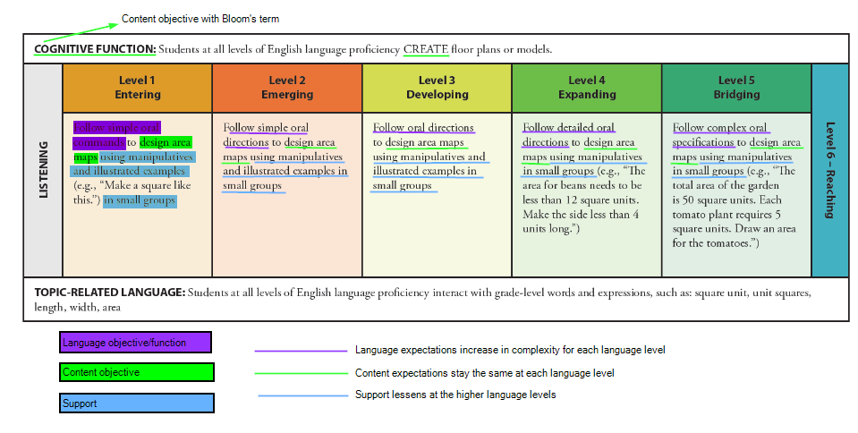
Annotated from: http://www.wida.us/standards/eld.aspx

